Game of Towers
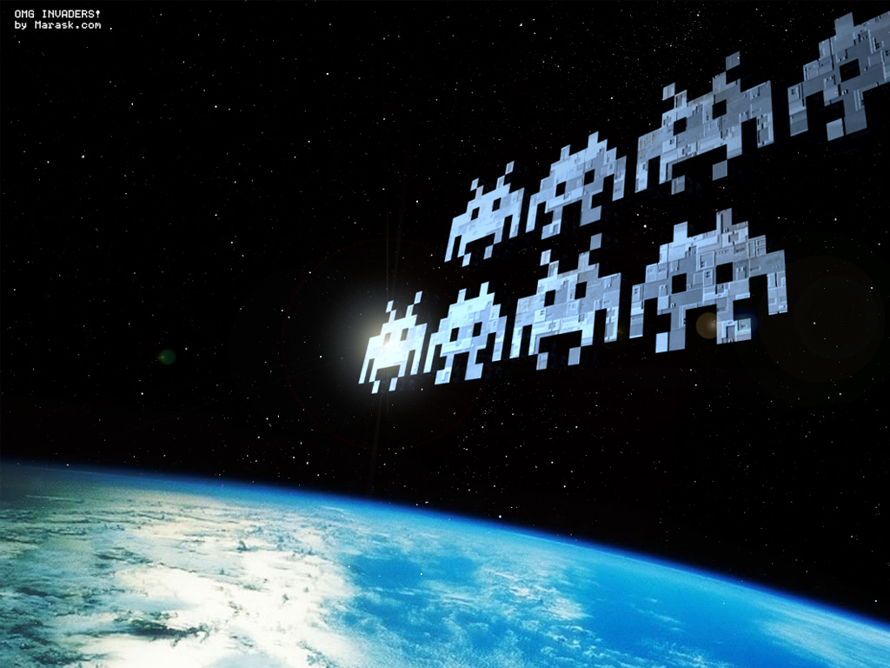

Game Design Document
Version 0.1
- Table of Contents

2 Design History 4
3 Team Personnel 5
4 Section I - Game Overview 6
4.1 Game Concept 6
4.2 Genre 6
4.3 Target Audience 6
4.4 Game Flow Summary 6
4.5 Look and Feel 6
4.6 Project scope 7
4.6.1 Environments 7
4.6.2 Levels 8
4.6.3 Characters 9
4.6.4 Projectiles 11
4.6.5 Power-Ups 11
5 Section II - Gameplay and Mechanics 12
5.1 Gameplay 12
5.1.1 Mission/challenge Structure 12
5.1.2 Objectives 12
6 Mechanics 12
6.1 Movement 12
6.1.1 General Movement 12
6.2 Win Conditions 12
6.3 Loss Condition 12
6.4 Screen Flow 13
6.4.1 Screen Flow Chart 13
6.4.2 Screen Descriptions 13
7 Section III – Interface 13
7.1 Visual System 13
7.1.1 HUD 13
7.1.2 Rendering System 14
7.1.3 Lighting Models 14
7.1.4 Camera 14
7.2 Control System 15
7.2.1 Keyboard Controls 15
7.2.2 Mouse Controls 15
7.3 Menu and General Game Usage 16
7.3.1 Splash Screen 16
7.3.2 Main Menu 16
7.3.3 Option Screen 16
7.3.4 Pause Menu 16
7.3.5 Win Screen 16
7.3.6 Loss Screen 16
7.3.7 Credits 16

Design History

Changes | Date
Original Draft | 9 September 2013

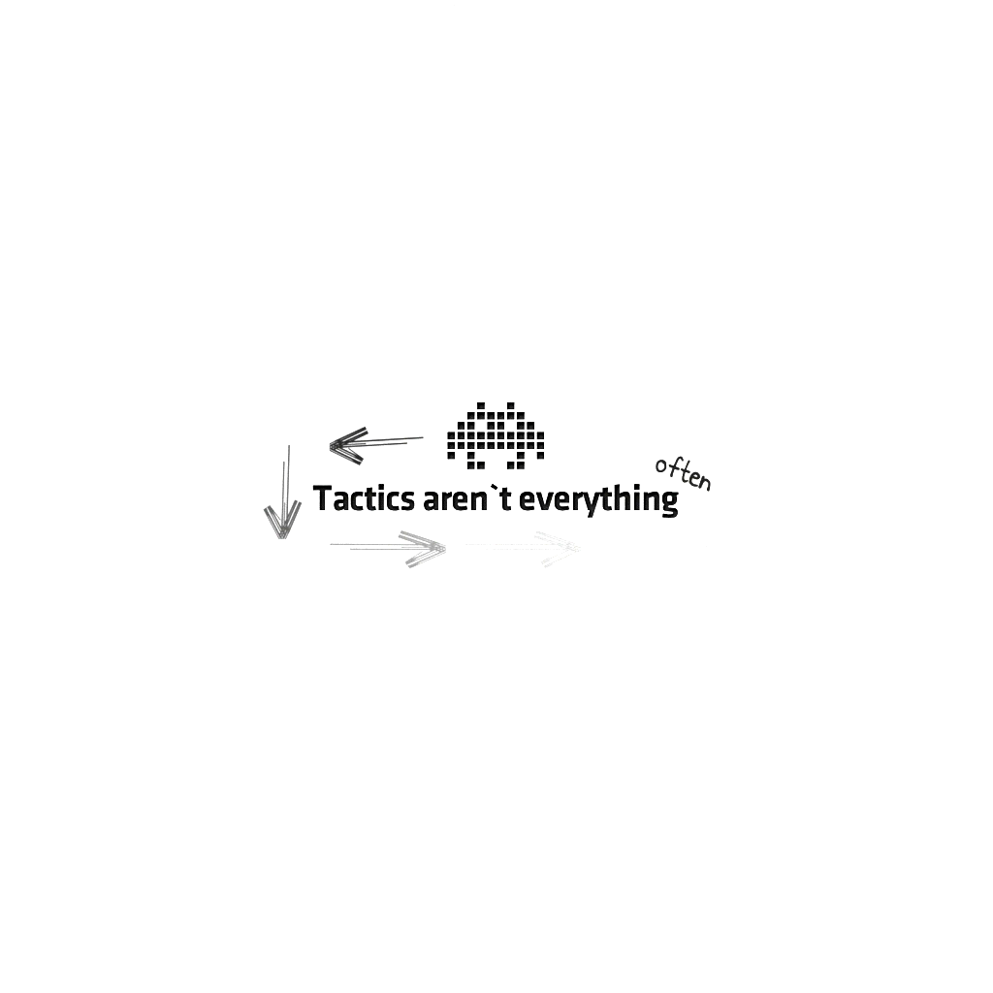

Team Personnel

Neilson Leslie | Programmer
Brandon Coulthard | Programmer
Jonathon | Programmer

Section I - Game Overview

Game Concept
The game “Game of Towers” is a simple tower defense game. The player will try to eliminate waves of “invaders” and stop them from destroying his castle/tower.
Each level has a single waves of enemies with each level introducing a new enemy or combination of previously encountered enemies. As the player is able to accomplish the task of defeating each wave, the next wave becomes more difficult. Instead of being stationary objects, various enemies have special attributes about them. Some enemies move faster than others, some requires to be hit by the player’s more than once before that enemy is defeated. The projectiles from the enemies are also destroyable by shooting before they hit the castle/tower

Genre
The game genre is an action game.

Target Audience
The audience that this game will appeal to will be all ages and test the player visual and reflexes while employing a fun factor and imaginative immersion.
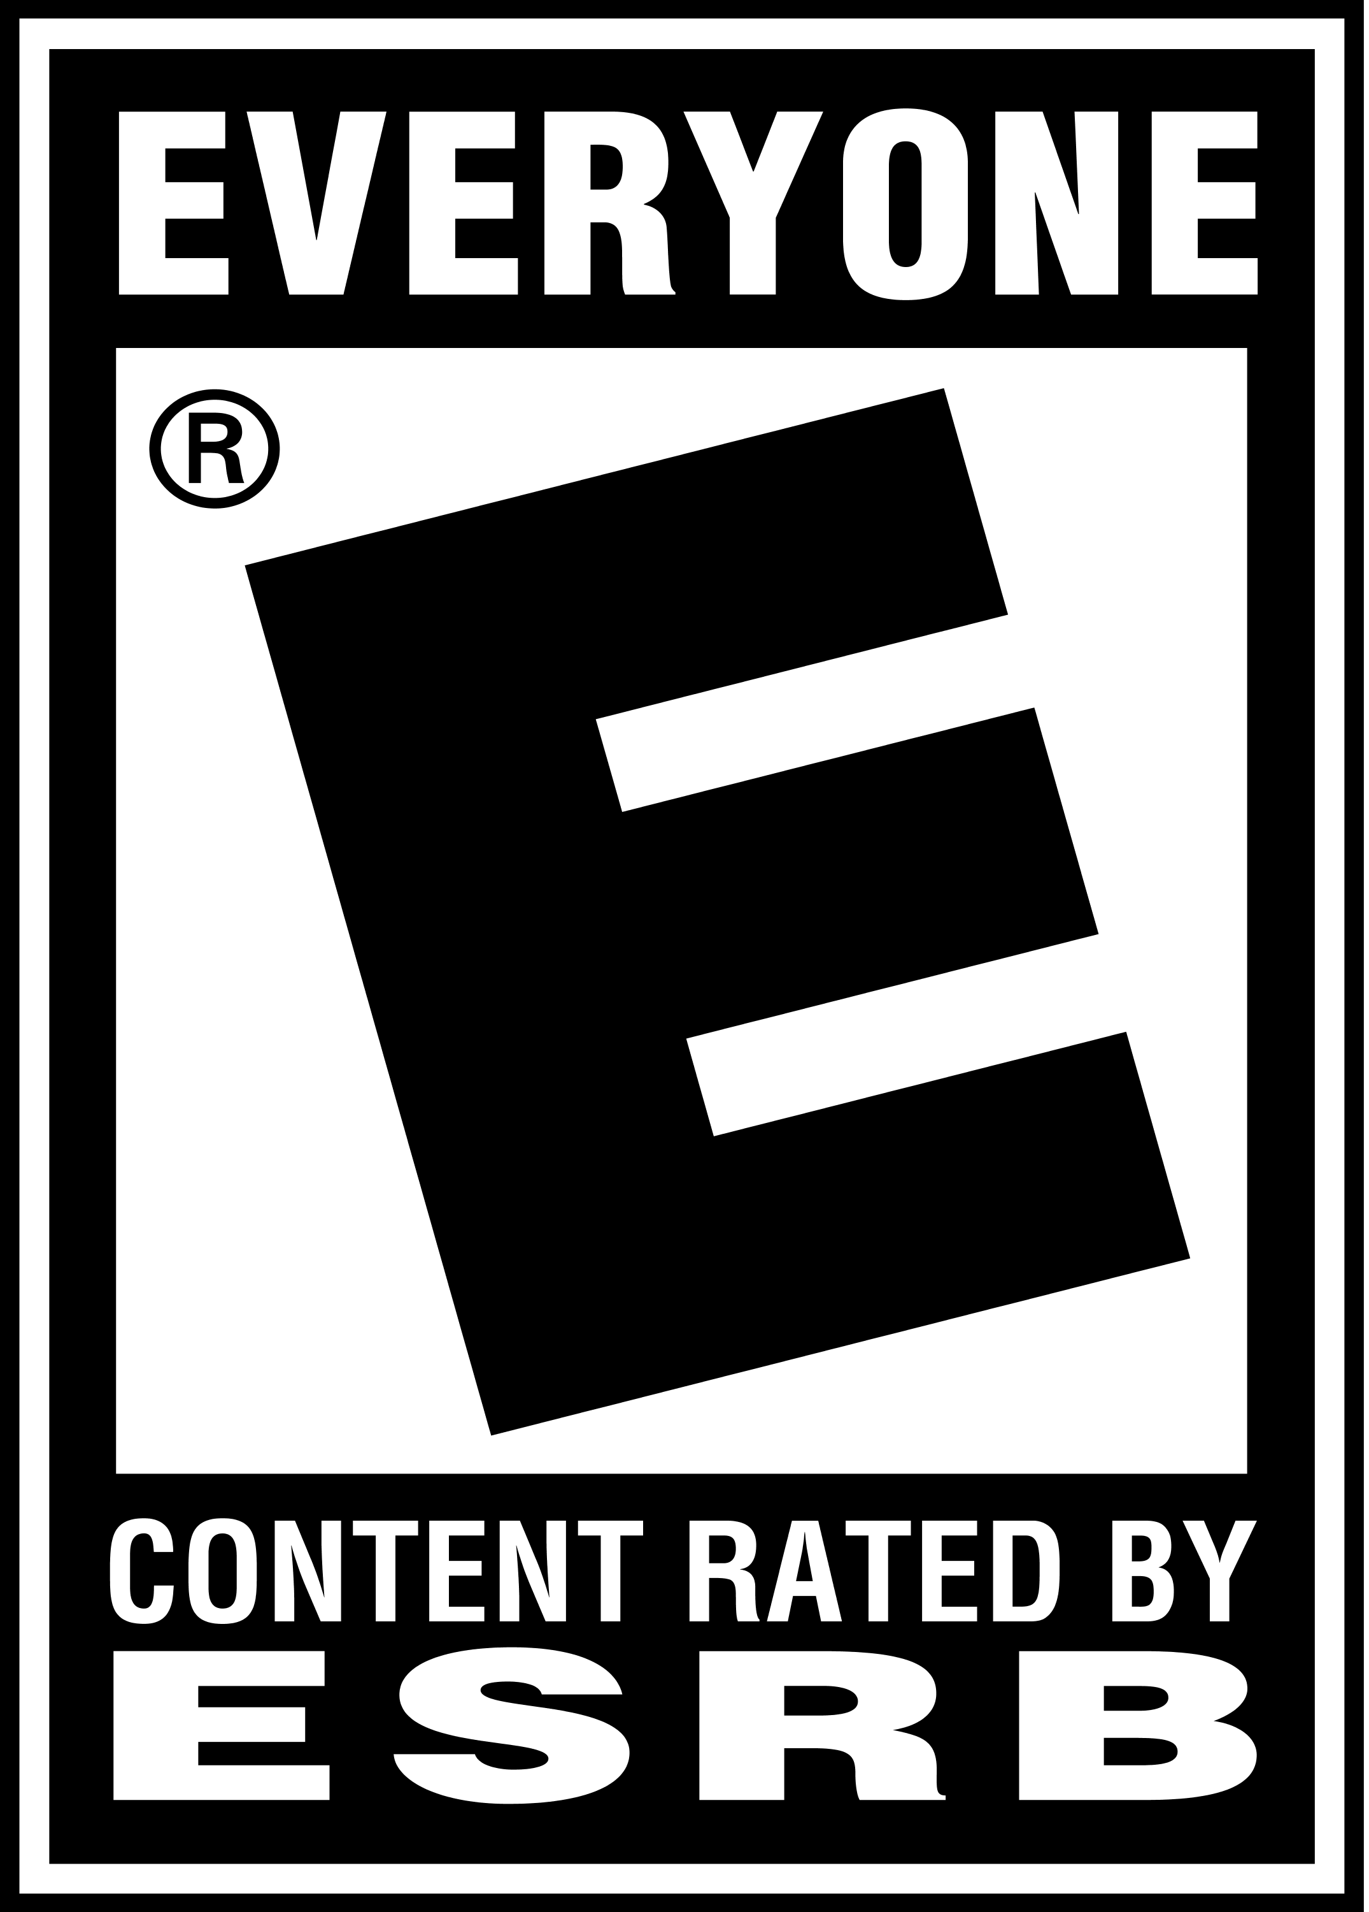

Game Flow Summary
The player progress through each level. To progress to the next level, the player must destroy all enemies for that level. There is no limit on levels, simply play until you get a game over.

Look and Feel
The plot is that the player is a Master Wizard and the player sole goal is to defend the castle/tower from an onslaught of enemy invaders. As the user/player you have to guide the direction of the Wizard’s attack to stop the invader’s enemy fire as well as eliminating the invaders themselves. This is a battle for the survival of your kingdom and you are their last hope. Prove your mettle and show those invaders that the Kingdom of Fiore is strong and will not be defeated. Beat the mission and come home a hero!!

Project scope

Environments
The environment will never change. The terrain will be constant and the position of the castle/tower will always be in the center.

Location – The Kingdom of Fiore
The Kingdom of Fiore will be what the player is defending. The Castle/Tower has a total of 30 hit points in total, so if an enemy projectile gets past the player 1 hit point will be deducted. If Castle’s hit points reach zero the game is over.

Levels

(come back to this once level calculations are defined)

Characters
The characters within the game is the avatar representing the player and the various enemy types. The player is represented by a wizard-type sprite standing in the center tower of the castle. The enemies vary in type and colour to quickly identify their differences in abilities and attributes. Each level introduces a new enemy to utilize in combination with previously encountered enemies.

Wizard
The Wizard will be the player controlled avatar used to defend the castle and stop the invaders. The wizard will be restricted to the Y axis and X axis. Motion is positive and negative rotation movement about the Y axis.

The Wizard: 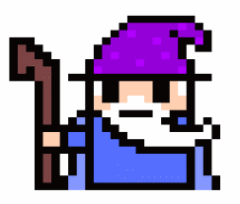

Enemies
All enemies will attack from the sky dropping bombs onto your castle which you must shoot down. There are also siege weapons that come onto screen on top hills at random points in the game and file projectiles at the castle.

There will be three different types of enemies:

Airship #1: attack every 2s
Drop a single bomb vertically
Damage = 5 points
Move at a constant speed across the screen
Armour = 0
Health = 10 points

Airship #2: attack every 2s
Drop a two bombs vertically
Move at a constant speed across the screen
Armour = 2 points
Damage = 5 points
Health = 10 points

Airship #3: attack every 2s
Drop a two bombs vertically
Move at a constant speed across the screen
Armour = 4 points
Damage = 5
Health = 12 points

Seige Weapon #1 (Ballista): attack once then leave
Fire a single projectile
Damage = 3
Armour = 0
Health = 10

Projectiles
There are four types of projectiles in Game of Towers, three of which are enemy attacks and one is the player’s defensive attack.
Magic Orb Attack: The wizard shoots this projectile at the enemies in order to defend the castle.

Bombs: Ships drop bombs vertically down onto the castle which explode upon impact.
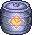
Siege Weapon Bolts: The siege weapons fire bolts at rapid pace at the castle. They do less damage than bombs or fireballs but fire at a much quicker pace.
Fireballs: Dragons shoot fireballs that deal a high amount of damage that take multiple hits to destroy.


Power-Ups

Ships can drop a power up at random points when they are destroyed which give the player either a damage increaser, or a health restore power up.

Damage Increase:

Increase player damage for 15 seconds by 5 points
Damage Power-Up:

Health Restore:

Will increase castle health by 10 points but won’t increase it beyond the castle health capacity.
Health Power-Up:

Section II - Gameplay and Mechanics

Gameplay

Mission/challenge Structure
The game will take place just outside of earth’s orbit in the vast emptiness of space. The player will be in control of an earth defence spaceship called The Paddle. The Paddle is the last line of defense against an alien invasion.

Objectives
The objectives of the game are:
- Successfully defend the planet from each wave of invaders.
- Armed with a ball accurately ricochet and aim the ball to destroy every invader and stop the advance.
- Complete each level successful to beat the game.
- Don’t let the planet’s hit points reach zero.

Mechanics

Movement

General Movement
The general movement is the position the wizard is looking at but neither his X value or Y value ever change. You use the mouse to point where the wizard is looking at and his sprite matches the direction the mouse is at.

Win Conditions
The player tries to get the best high score possible to be recognized on the leader board. The leader board records the total time the player survived the game and is placed on the leader board rankings. Complete the game as fast as possible.

Loss Condition
The castle’s health reaches 0 the game has ended and the player has the option to replay the game or quit. A game over message will be displayed.

Section III – Interface

Control System

Mouse Controls
The mouse will use the mouse down function to fire the wizards attack. No other controls are needed.

Menu and General Game Usage

Splash Screen
Shows a picture of the castle you are defending.

Loss Screen
If at all through the game any loss condition is achieved a screen will pop up with two buttons: Retry or Quit. Retry will start that level from the first wave.

